Pymaceuticals Mouse Treatment Analysis

The overall goal of this analysis is to compare the performance of various treatment regimens against a company’s regimen named Capomulin. This has been done by taking and displaying various basic information like how many times mice were able to be observed during certain treatment (Fig. 1) as well as the sex percentages of the mice used (Fig. 2). The size of the initial tumors was also checked compared to the average weight of the mice and there was some correlation found as heavier mice had larger tumors (Fig. 3).

Overall Capomulin proved to be quite effective at treating tumors found on the mice. In one mouse’s tumor size was reduced to almost half its size by the end of the observation period (Fig. 4). It also managed to have some of the smallest final tumor sizes by the end of the trials. The treatment Ramicane also managed to produce lower final tumor sizes, while Infubinol and Ceftamin still had relatively larger sizes by the end of the treatment observations (Fig. 5).

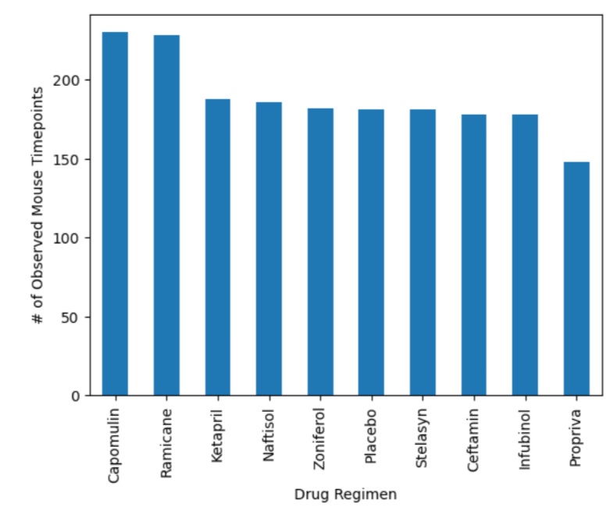

Figure : Number of timepoint observed per treatment

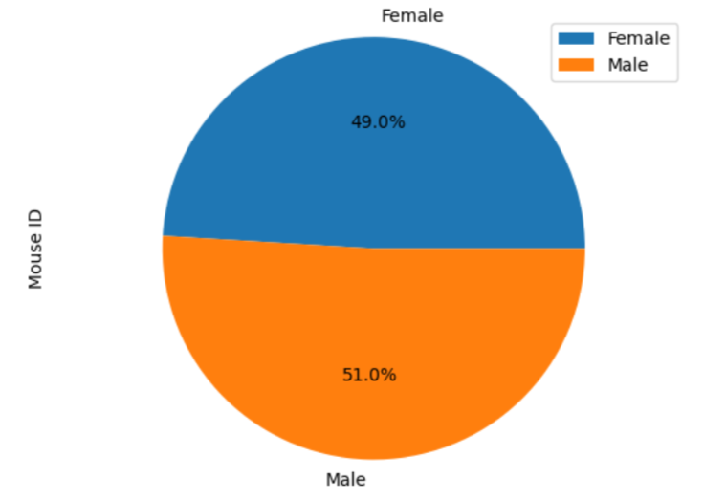

Figure : Sex breakdown of Mice in treatment

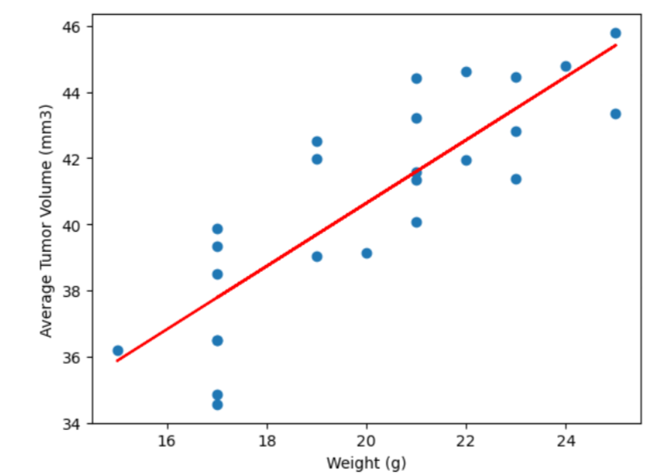

Figure : Average tumor volume vs. weight

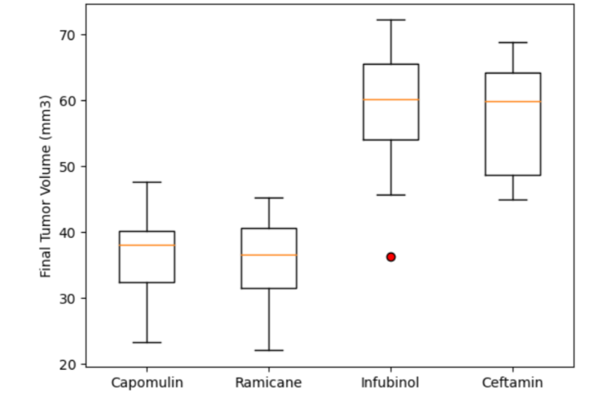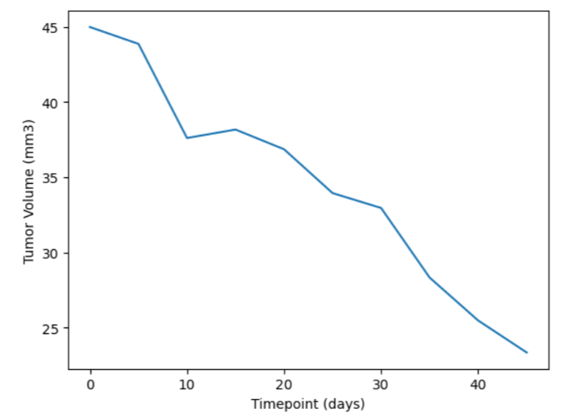

Figure 5: Boxplot comparing final tumor sizes of 4 treatments.

Figure 4: Tumor size of mouse on Capomulin throughout treatment